# **Solutioning in Blockchain**

How do you imagine the future of the world financial system? E-banking, contactless payment, and cryptocurrency markets are among the things that are already real. The ability to make transactions and payments in a secure way without having to pay commission fees can fundamentally change the financial industry in the future. This is possible with Blockchain technology. Its important to get the Fundamentals right and be ready for Blockchain.

Recently we have seen lot of discussions & collaborative efforts to experiment around — **Blockchain**. It’s being widely debated and has become the new buzz word for multiple industries, especially banking. & As we are experiencing more experimentation and collaboration my interaction around **Blockchain** has increased with peer Banks,start-ups, various Accelerators

“The BlockChain will take another few years (2-3) before it is mainstream, as it’s changing the foundations, the rails, the roads of finance. It’s not just a bit of froth on the foundation, like most of the apps out there. After all, the mobile telephone was invented in 1973 but took almost thirty years to become mainstream.”

As per my experience at Bankchain, Banks across the country have successfully initiated collaboration with specialized Technology Firms (Fintech) and/or consulting firms to build proof-of-concepts and explore various potential use-cases. This implies the seriousness of banks towards the Blockchain technology and its eagerness to understand how Blockchain can address and resolve few pain points in the current state process. Board Members, Management committees are discussing around incorporation of BlockChain in their Strategy. This shows "**Awareness**" stage has surpassed for most of banks !!

While we are diving into Blockchain, its important get the fundamentals right. It’s important to decide the direction and expected results around investments we will put in for BlockChain Drive. Just like for any technology, its success depends on its Use case, Blockchain is not an exception. For banks it’s important to perform, experiment with multiple use-cases on Blockchain before decide on actual potential use case & right choice of Blockchain technology. While experimentation is necessary to validate a solution, it is important to first select the right use-cases to implement a BlockChain based solution.

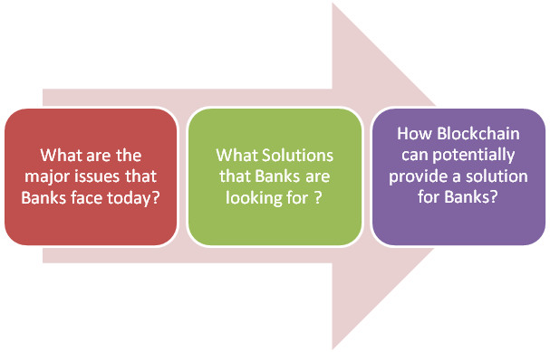

**1. What are the major issues that Banks face today?**

a. Rising costs of operations

b. Increasing susceptibility to fraudulent attacks on centralized servers

c. Challenges in ensuring transparency.

d. Requirement of intensive manual processing and documentation

e. Involvement of costly intermediaries

**2. What Solutions that Banks are looking for?**

a. New ways to perform transactions quicker for an enhanced customer service

b. Cost efficiency in its operations

c. Assuring transparency to customers and regulators.

d. Safe & Secure Solutions

**3. How Blockchain can potentially provide a solution for Banks?**

a. It inherently helps eliminate intermediaries.

b. It maintains immutable log of transactions.

c. It also facilitates real-time execution of transactions.

d. This could potentially reduce the TAT for banking transaction

e. It reduces costs of manual work

Blockchain is like the internet before the browser. The first generation of the digital revolution brought us the Internet of information. The second generation — powered by blockchain technology — is bringing us the Internet of value: a new platform to reshape the world of business and transform the old order of human affairs for the better.

Banks should leverage full value of Blockchain. It can be achieved by choosing the right ‘use case’ to enhance customer service and satisfaction. To choose right Usecases let’s follow below Framework of 6 Ts –

**1.** **Turnaround Time**— Will the transactions benefit from being real-time or synchronous? How much time it will take to complete a transaction?

**2.** **Task Involvement**— Does the process involve manual Tasks? How Settlement & Reconciliation will be handled?

**3.** **Trust**— Is there trust among participants? How multiple participants are involved?

**4.** **Transparency**— Are multiple participants involved? Does transparency into the transaction help the participants? How information being stored in multiple locations by multiple participants?

**5.** **Test & Certify**— Is the documentation paper based? Are there reports required to be generated? Is data consistency an issue?

**6.** **Ticket Cost –**Is there any latency due to processing through intermediary? Does the intermediary exist due to lack of a trust? Is there any cost involved to maintain intermediary?

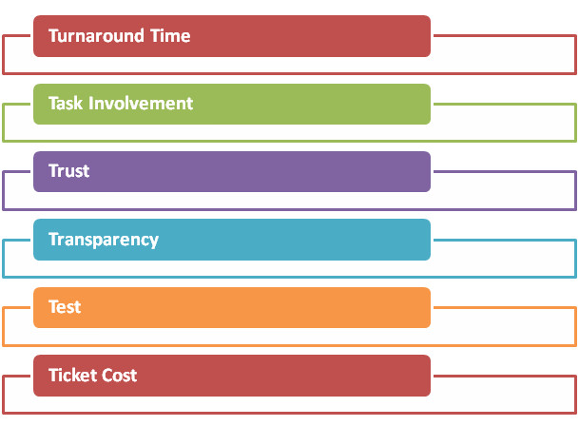

***“Answer should be “YES” in all 6 Ts Question to adopt Blockchain as a Use Case! We will see Blockchain technology is moving into the financial mainstream”***

**4 Challenge Pillers**

I must say, it is important that Banks should understand the key fundamentals of this technology and how it can solve the current business issues as on one hand. This will involve answering a series of fundamental questions related to dynamics of transaction, regulations available skills & technology underlying–

**1.** **Dynamics of Transaction:** Such as cost of implementation of the Blockchain based solution, structure of Blockchain i.e. public, private or consortium, and key stakeholders can be answered by the bank.

**2.** **Regulations:** It will have to be resolved through focused discussions with competent regulatory authorities and incorporation of their thought-process. Banks will also need to have a concrete plan for transaction scalability.

**3.** **People & Skills**:It will be answered by hiring right people , training or collaborating with matured Technology Partners

**4.** **Technology:** Technology challenges are around Scalability, Privacy, Latency & User interface security. It will be answered by Technology companies helping banks to do proof of concepts & decide on right Blockchain technology to use for certain use case. It’s very important identify right Blockchain Technology.

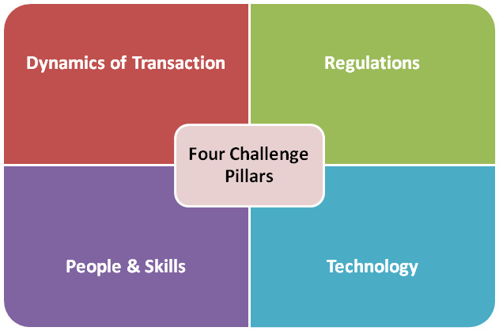

Going forward Banks will have to opt for many approaches to specialise into Blockchain. Bank need to identify opportunities, determine feasibility and impact, and test proof of concepts. For success Blockchain implementations, Collaboration with Technology Partners & Other banks will be a success Mantra ahead.

*Blockchain is a vast, global distributed ledger or database running on millions of devices and open to anyone, where not just information but anything of value — money, but also titles, deeds, identities, even votes — can be moved, stored and managed securely and privately. Trust is established through mass collaboration and clever code rather than by powerful intermediaries like governments and banks.*

**Annexure - Difficulties faced by blockchain technologies**

The use of blockchain technology in other industries, except for FinTech, is rather a controversial issue due to the number of challenges that should be overcome.

1. Emerging technology. Solving such problems as the verification process and data limits will be critical to making the blockchain widely acceptable. Moreover, it will take time before the public will be ready to entrust their data to this technology.
2. Uncertain normative status. Since currencies are created and regulated by national governments, the status of blockchain in government regulations remains unsettled.
3. High energy consumption. The numerous attempts to verify transactions demand significant computing power.
4. Cost. The technology offers huge savings in costs and time of blockchain transactions, but the initial integration cost can be a deterrent.
5. Integration. The creation of blockchain applications requires significant changes or the complete replacement of existing systems.

Therefore, before you jump into a brilliant blockchain-based project, you should work out a clear understanding of why you need this technology. After that, if you still want to use the blockchain technology, let's take a closer look at how you can build an app with a blockchain solution.

**Annexure B : The main advantages of the blockchain technology**

1. High level of blockchain security. Digital signature and a cryptographic encryption are aimed at providing a steady system of information recording.
2. Reduced hacking threat. Information that is simultaneously stored in multiple places can not be hacked or forged that easily.The original records can be immediately recovered from neighboring sources.
3. Increased transparency of operations. Banks and their corporate clients have an opportunity to receive almost real-time notifications about the completion of a payment or transaction, for example.
4. No payment for intermediaries' services. It is possible due to the fact that the system is decentralized.
5. Different levels of accessibility. The blockchain network can be open and accessible or private with limited membership.
6. Faster transactions. There is no need to include payment systems in the transaction process and, as a result, the processing speed of operations is increased and the cost for the end user is reduced.
7. Automatic reconciliation of accounts. As the authenticity of transactions is checked by the participants themselves, they also confirm their authenticity and form blocks of records, etc.

# **When to use Blockchain…**

